Case 1-EUR-France-Paris Basin-White Flint-Mid Paleo-Mousterian-Levallois-Homo Neanderthalensis-100-30 kya
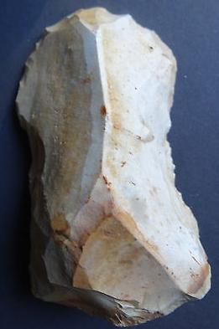
EUR-France-Paris Basin-White Flint-Mid Paleo-Mousterian-Levallois-Homo Nenderthalensis-100-30 kya
Case no.:
Accession Number:
Formal Label: EUR-France-Paris Basin-White Flint-Mid Paleo-Mousterian-Levallois-Homo Neanderthalensis-100-30 kya
Display Description:
LC Classification:
Date or Time Horizon: 100-30 kya
Geographical Area: Paris Basin
Map:
GPS coordinates:
Cultural Affiliation: Paleo-Mousterian-Levallois
Medium: White Flint
Dimensions:
Weight:
Condition:
Provenance: Old French Collection
Discussion:
References:

